**3.1.3 Bowlers**

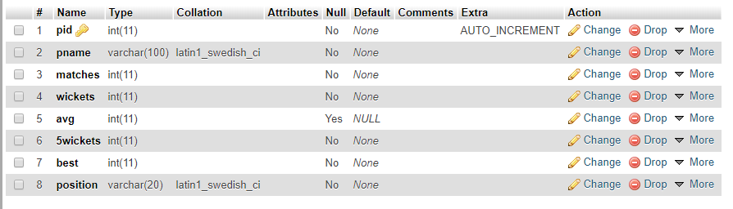

Fig 3.1.3 Bowlers

In the above fig 3.1.3, There are 8 attribute where Primary key is pid.

**3.1.3 All-rounders**

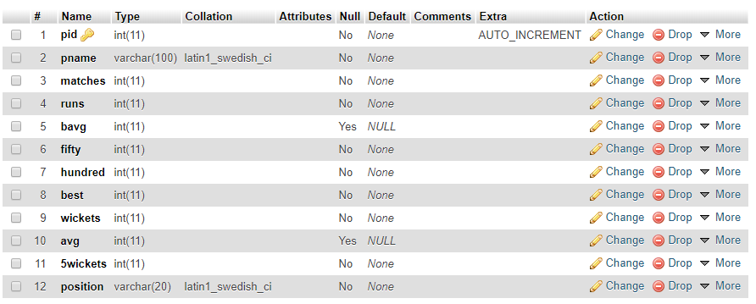

**3.1.4 Players table**

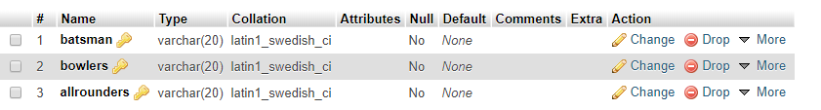 Fig 3.1.4 players table

In the fig 3.1.4, There are 3 attribute where all 3 are composite Primary key in each are foreign key to all others tables Batsman, Bowlers and Allrounders.

**3.1.5 Team**

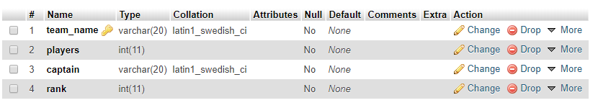

In the above fig 3.1.5, There are 4 attribute where Primary key is team name and Foreign key is also team name and captain.

**3.1.5 User_Team**

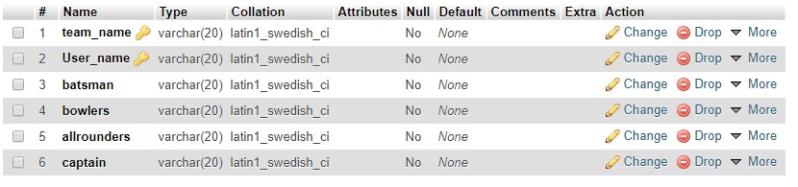

In the above fig 3.1.7, There are 6 attribute where Primary key is team name and user name and Foreign key is batsman, bowlers and all-rounders.

**3.2 PHP and Database Connection**

* PHP provides built-in database connectivity for a wide range of databases – MySQL, PostgreSQL, Oracle, Berkeley DB, Informix, Lotus Notes, and more.
* Use either mysql_connect or mysql_pconnect to create database connection.
* mysql_connect: connection is closed at end of script (end of page).
* mysql_pconnect: creates persistent connection -connection remains even after end of the page.
* Connect to the MySQL server
  + $connection = mysqli_connect("localhost", “root”, “password”, “databasename”);
* Access the database
  + mysql_select_db("databasename", $connection);
* Perform SQL operations
* Example: $result = mysql_query ($query, $connection)
* Disconnect from the server
  + mysql_close($connection);

